Vanier College

User Guide

  Client: Opeq, Simon

System Development Section 01

Team Orange:

Jiamin Yuan

Dinal Patel

Craig Justin Balibalos

Alihan Djamankulov

Ibrahim Awad

Submission Date: 12 December 2022

1. An employee can login by inputting their name into the and click on the connect button in the current interface.

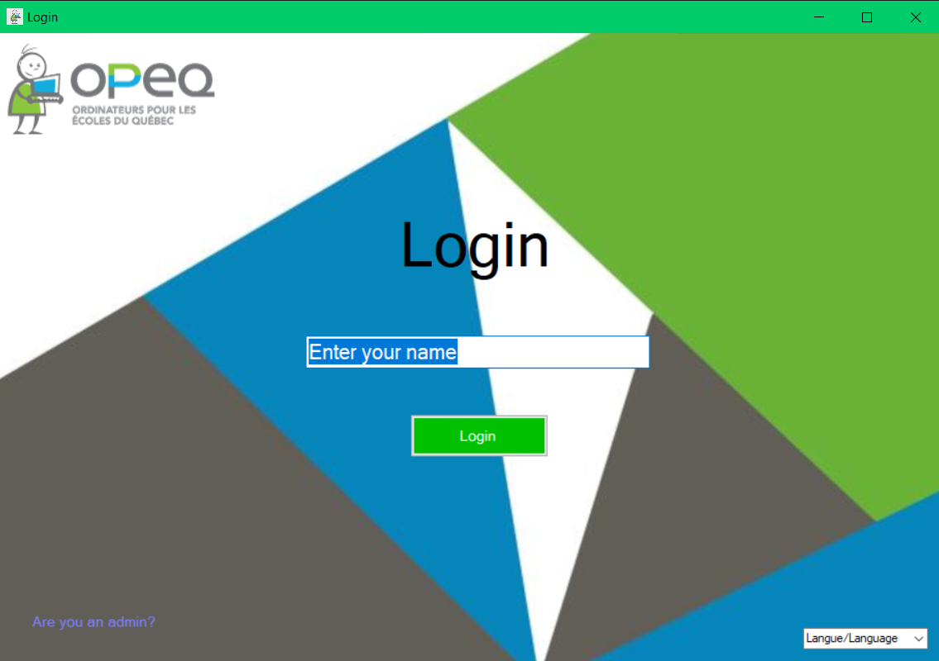

2. Once the user has login successfully, they will be redirect to welcome interface. User can select add data, modify data or view data in the left navigation bar.

3. On add page, user can add a new record by input client name, description, date, how contacted, contact info, type of problem, barcode. Once all the information has been filled, they can click on the add button to save it to database. Or they can click on cancel button to not save the data to database, then it will redirect to the main hub.

4. On modify page, user can update or modify based on new information. The existing data will be loaded using the matched barcode it found according to search bar input. Some of the new data fields to be saved: type of order, order number, address, problem solved, action took, new order. Once all the information has been filled, they can click on the add button to save it to database. Or they can click on cancel button to not save the data to database, then it will redirect to the main hub.

5. On view page, user can view all the existing record. The user also has the option of conducting a specific record search for a MAT, Order number, or client name. Or filter all the unsolved, ongoing, solved record. The employee can choose a record from the result table to see its detailed information.

6. The user can view the details of a specific client by entering the MAT, all the info related to that specific record will be shown in the following page. The return button will take the user back to view interface.

7. If the user wants to login as admin, the purple hyperlink locates in the left bottom corner which will navigate to admin login interface. The user will be asked to enter their name and password.

8. As an admin, they can add or remove a type of problem, type of command, action took which will be available in employee’s side dropdown.

9. The user can change the language in both login pages

